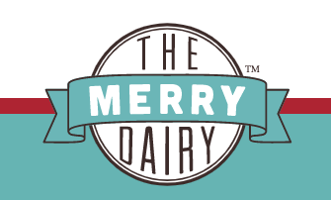
ORDER FORM
NAME:__________________ Phone Number: ___________
Pick your ice cream pints from the list below. All Merry Dairy products are peanut, tree nut and sesame-free, and there are also options for dairy-free (DF), gluten-free (GF), soy lecithin-free (SF) and vegan (V) flavours!
If you wish you can add a donation to support Indigenous Charities by choosing to add $5, $10, $25 or $50 to your order!
FLAVOR | PRICE ($10 per pint)
Chocolate (GF/SF) | $10 x ___ = $____
Chocolate Oreo (V) | $10 x ___ = $____
Vegan Coffee (V/GF/SF) | $10 x ___ = $____
Cookies and Cream | $10 x ___ = $____
Earl Grey and Cherry | $10 x ___ = $____
Earl Grey and Shortbread | $10 x ___ = $____
Hibiscus Passionfruit (V/GF/SF) | $10 x ___ = $____
Honeycomb (GF/SF) | $10 x ___ = $____
Mint Chip (GF) | $10 x ___ = $____
Raspberry Cheesecake (GF/SF) | $10 x ___ = $____
Rum and Raisin (GF/SF) | $10 x ___ = $____
Salted Caramel (GF/SF) | $10 x ___ = $____
Strawberry (GF/SF) | $10 x ___ = $____
Strawberry Coconut (V/GF/SF) | $10 x ___ = $____
Vanilla Ice Cream (GF/SF) | $10 x ___ = $____
Add $ Donation for Indigenous Charities  (Circle amount wish to donate) | $0, $5, $10, $25, $50
TOTAL
PAYMENT DUE AT PICK-UP
All orders will be available for pick up at the Merry Dairy Truck which will be
at Rideau Park United Church on Sunday, June 25th from 11am-12:30pm
Call Diane Lagace at 613-421-8722, or email:dlagace@uottawa.ca if any questions, or if you prefer to organize home delivery anywhere in Ottawa (minimum $40 order; delivery between 3-7pm Wed-Sat to any address in Ottawa).
Last day to hand in order form at church: Fri. June 23 2023

